

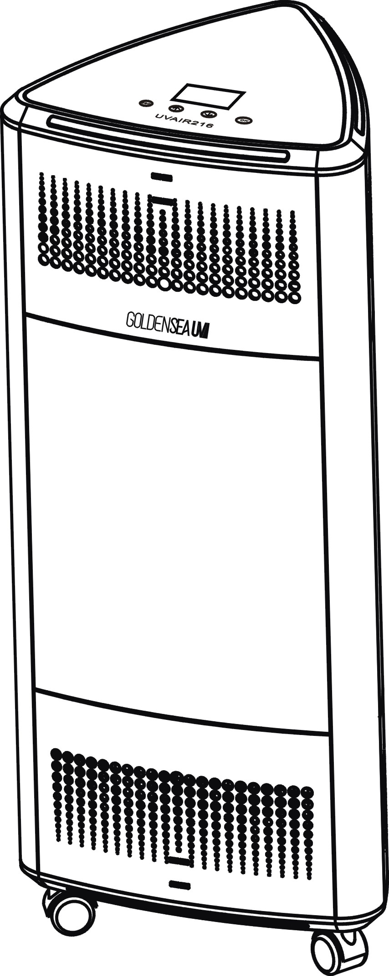

UVAIR216

USER MANUAL

KEEP THIS MANUAL FOR FUTURE NEEDS 

Thank you for purchasing a GOLDENSEA UV product. You have acquired a powerful and versatile product. We are confident that you will be satisfied with our excellent product and service. For your own safety, please read this user manual carefully before operating the product.

Contents

1. Product Overview 3
2. Control Panel Overview 3
3. Using The Product 5
4. Moving The Unit 8
5. Fall Protection 8
6. Open Door Protection 8
7. Dimensional Drawings 9
8. Replacing and Cleaning The Filters 9
9. Replacing The UV Lamps 11
10. Troubleshooting Tips 13
11. Features 14
12. Cleaning and Maintenance 14
13. Recycling 14
14. Service 14

Voltage Input: AC100-240V~, 50/60Hz; Power: 450W; Product Size: 457x429x1075mm

This product is for commercial use, such as in conference rooms, offices, hotels, schools, theaters, waiting rooms, restaurants, etc.

IMPORTANT!
When using electrical equipment, basic safety precautions should always be followed.
READ AND FOLLOW ALL SAFETY INSTRUCTIONS carefully before using this product, save it for future reference.

• Check and make sure the voltage indicated on this product corresponds to the local power voltage before connecting this product to the power socket.
• Do not use this product if the plug, power cable, or the product itself is damaged. If anything damaged, it must be replaced or repaired before using, to avoid a hazard.
• Always place and use the product on a dry, stable, level and horizontal surface. Do not use the product in wet surroundings or in surroundings with high ambient temperatures, or near gas products, heating devices or fireplaces.
• Do not use the product in a room with major temperature changes, as this may cause condensation inside the product.
• If you need to move the product, disconnect the product from the power supply first. Do not move the product by pulling its power cable.
• Always engaged the wheels brakes during use or storage, to avoid accidentally moving by itself.
• Do not block the air inlet and outlet by placing any items on the air inlet and outlet.
• Do not use this product for other than intended use.
• Make sure that foreign objects do not fall into the product through the air outlet.
• Do not let water, other liquid or ﬂammable detergent enter this product, to avoid risk of electric shock or fire hazard.
• Do not sit or stand on the product. Sitting or standing on the product may lead to potential damage or injury.
• Do not clean this product with water, other liquid, or ﬂammable detergent, to avoid risk of electric shock or fire hazard.
• Always unplug the product after use and before cleaning, or carrying out other maintenance or replacing any accessory.
• Only use the original accessory specially intended for this product. Do not use any other accessory. The use of accessory not recommended by the manufacturer may cause an unsafe condition.

Product Overview

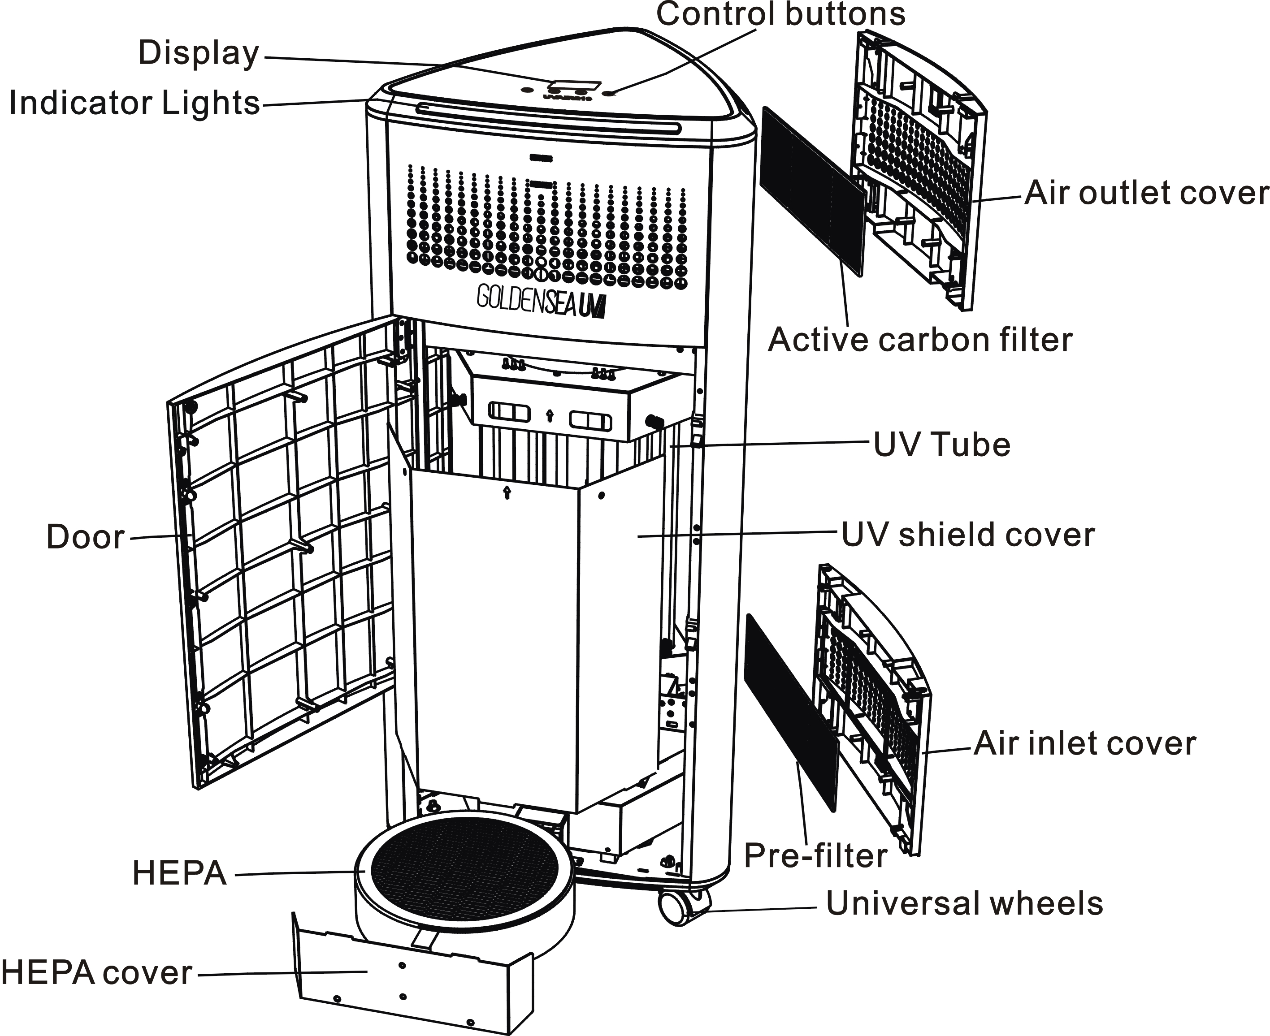

Control Panel Overview

Display Panel:

 | Fan Speed
 | |
Time Mode - | 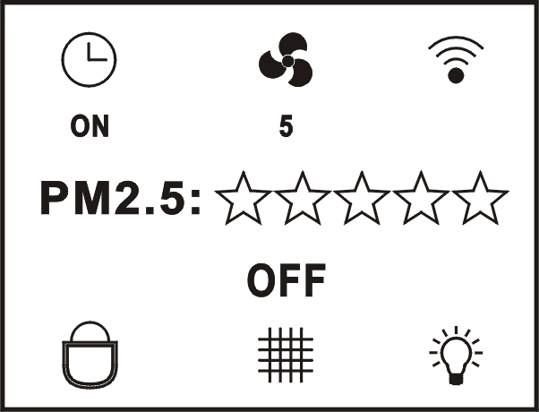 | - WIFI indicator
PM2.5 Indicator -
 |  | - Status and Alert
Key Lock - |  | - Lamp Replacement Indicator
 | |
 | Filter Replacement Indicator

Control Buttons:


 | Touch to Select the function in main menu
 | Touch to go Up to select different setting
 | Touch to go Down to select different setting
 | Touch to Start or Stop operation, or Enter the selected setting
 | 4 Time Modes: ON (continuous); 60 min; 90 min; 120 min
 | 10 Fan Speeds: from 1(low) to 10(high)
 | WIFI connected; select it and pressing for 5 seconds to reset
 | WIFI disconnected
 | Key unlocked: pressing + for 5 seconds
 | Key locked: after 27 seconds no operation
 | Filter Replacement Indicator (white: normal; red: need to replace)  Select it and pressing for 5 seconds to reset
 | Lamp Replacement Indicator (white: normal; red: need to replace)  Select it and pressing for 5 seconds to reset
 | Alert: door opened during use, or fall protection
Status | ON: working; OFF: standby; XX:XX: time counting down
PM2.5 | 5 stars green: excellent; 4 stars yellow: good; 3 stars red: pollution
LCD Light | Off after 30 seconds no operation; On when touch any key
Indicator Light | Pressing + for 5 seconds to turn off indicator lights
Reset Default | Pressing + + for 5 seconds when the buzzer "di" sound, the fan, time and indicator light return to the factory default

Indicator Lights & Audio Alarm:
Status | Audio Alarm | Indicator Lights
Standby | / | Green Light  solid
Operating | / | Blue Light  solid
End of Cycle | Triple(3) Ping  every 10 seconds | Green Light  flash for 30 seconds
Fall Protection | Quadruple(4) Ping  every 10 seconds | Green Light  flash continuously
Door Opened | Quintuple(5) Ping  every 10 seconds | Blue + Green Lights  flash alternately

Using The Product

- Before Use

• Always place the product on a stable and flat surface with the universal wheels brakes engaged before and during use.
• For best purification and disinfection performance, close all the doors and windows.
• Keep curtains, clothes, papers, etc… away from the air inlet or outlet.

For air purification, this product can detect and provide the current PM2.5 feedback. Most of the indoor air pollutants fall under PM2.5, such as tobacco smoke, some bacteria, mold spores, dust, allergen, etc…. Air quality indications for reference:
Indications |  | PM2.5
 | Green | Excellent
 | Yellow | Good
 | Red | Pollution

This product is designed with UV lamps inside, the UVC can do high efficient disinfection to the air which going through this product during the air purification process.

High volume air change, up to 800 cubic meters per hour.

- Operation

Control Panel Operation:
- Connect the power plug of the product to the power socket.  - Press the switch 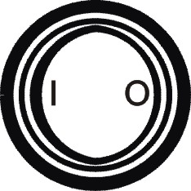 to < I > to power on, the indicator lights turn on green.  - Touch button to select your desired function in the main menu.  - Touch button or to select your desired setting (time mode and fan speed).  - Touch button to enter the setting and start the operation.  - Touch button to stop the operation. | 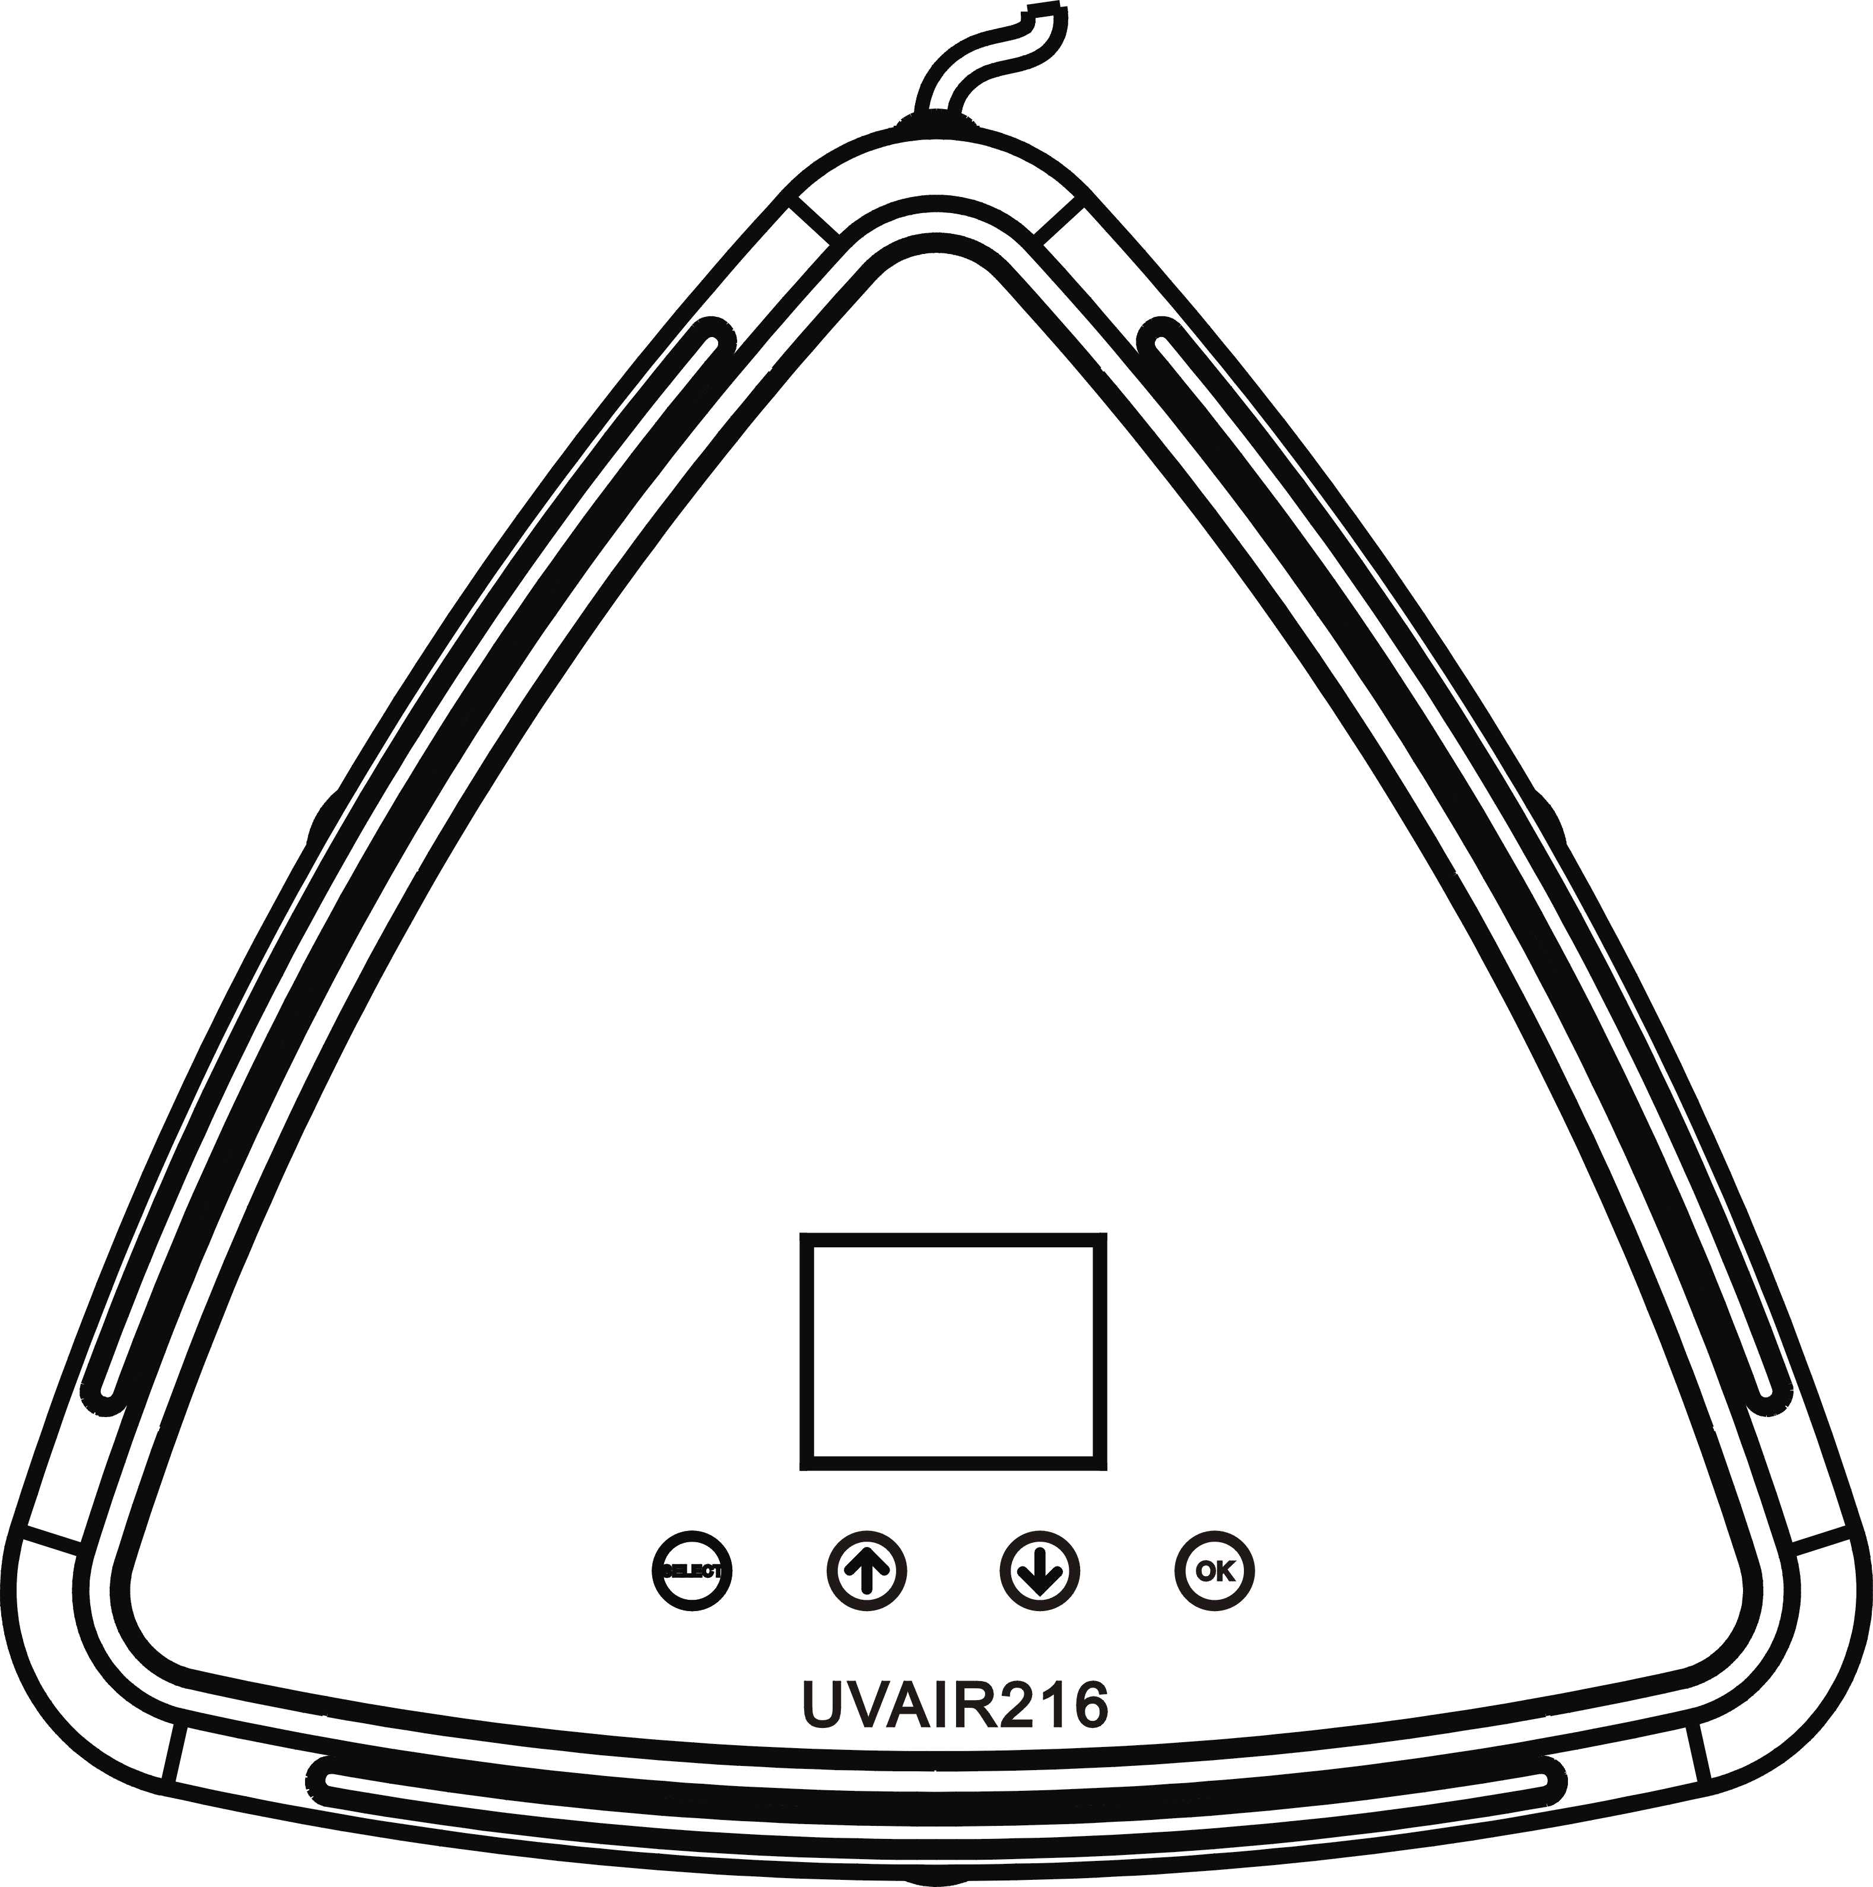
* If need to change the time mode after operation started, need to stop operation first.

Remote Control Operation:
- Connect the power plug of the product to the power socket.  - Press the switch to < I > to power on, the indicators turn on green.  - Press the button to start the operation.  - Press the button < - > or < + > to reduce or increase the fan speed. Or press the button < Max > or < Quiet > for quick access to the maximum or minimum speed.  - Press the button to stop the operation.  * Battery type for the remote control: CR2025. | 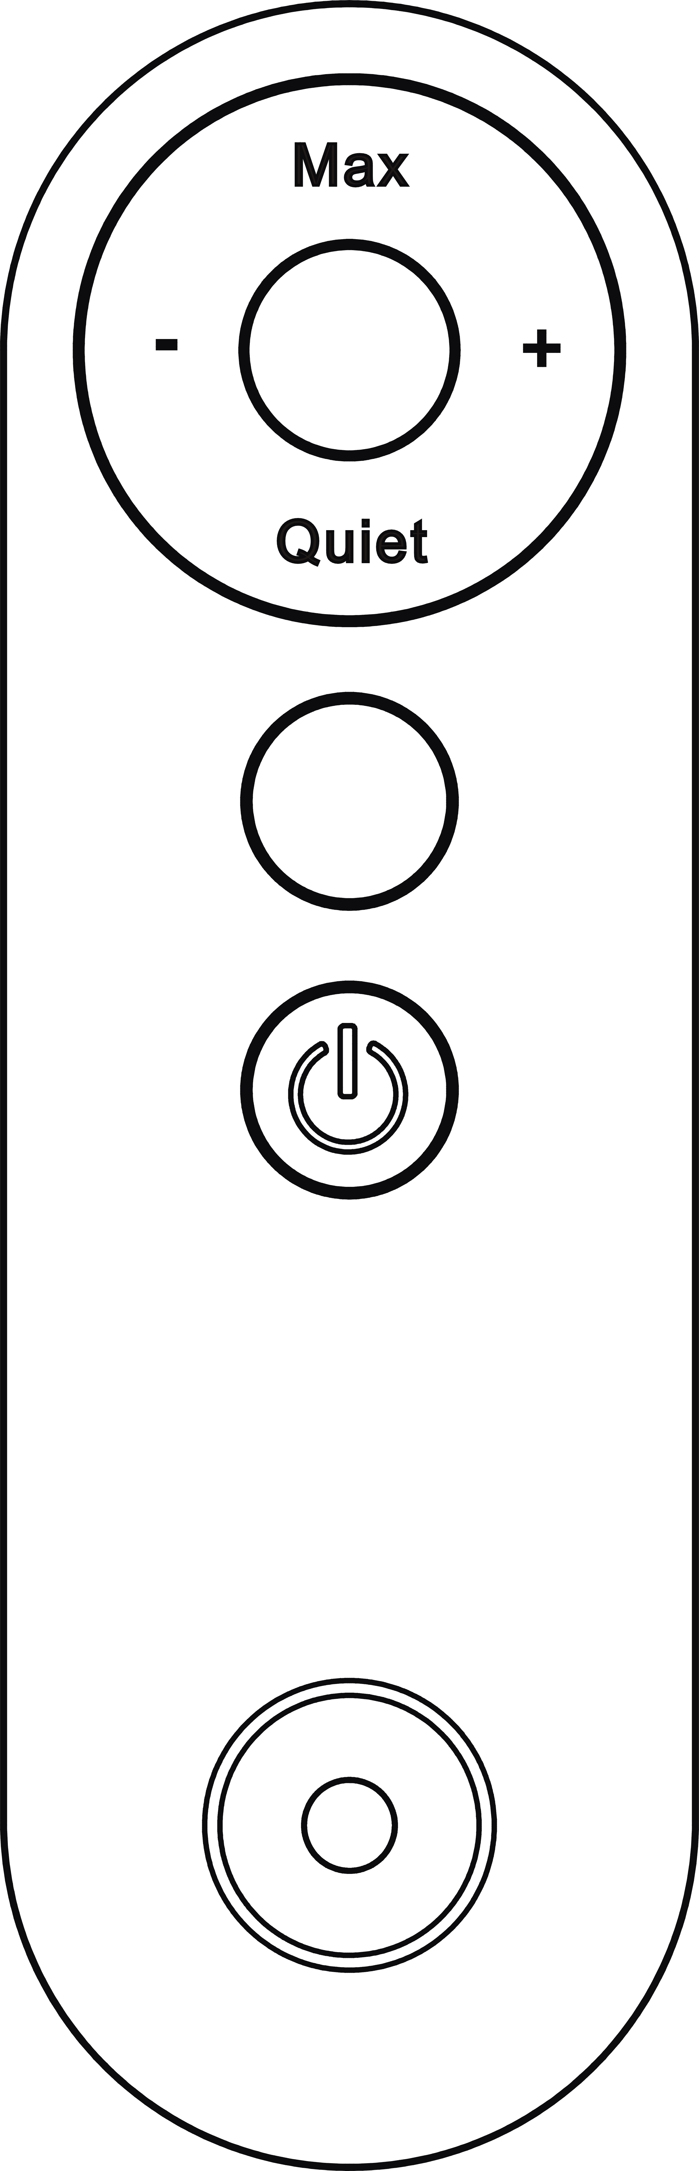

WIFI APP Operation

• Connect your mobile phone to the LAN network.
• Make sure the LAN network you connected is 2.4G WIFI, not 5G WIFI.
• One LAN network is only for one user to bind device, not for multi-user.

Download "GOLDENSEA UV" APP from App store or Android market and install into your mobile phone.
Steps to Connect your device to the LAN network and Bind:

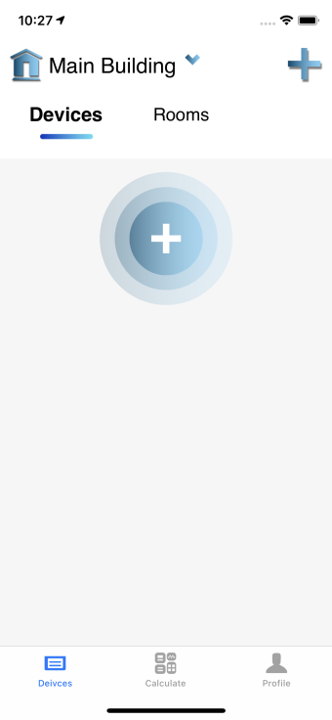 |  | 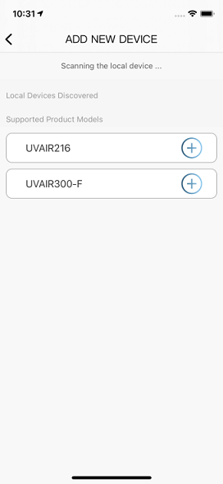 |  | 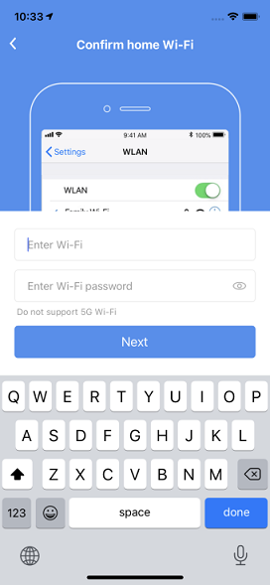
1. Launch the APP, click “ + ” to select and add new device. |  | 2. Click the device in the list which you want to connect. |  | 3. Input the WIFI name and password, click “Next” to connect.

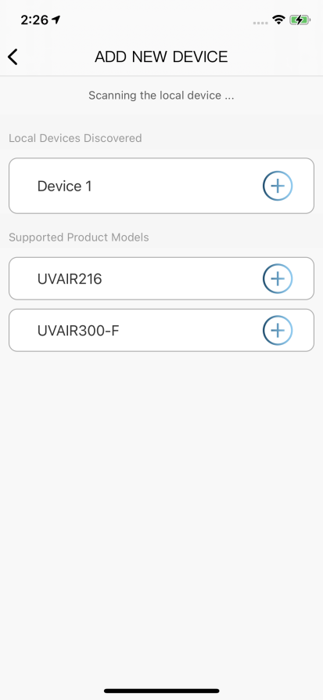 |  | 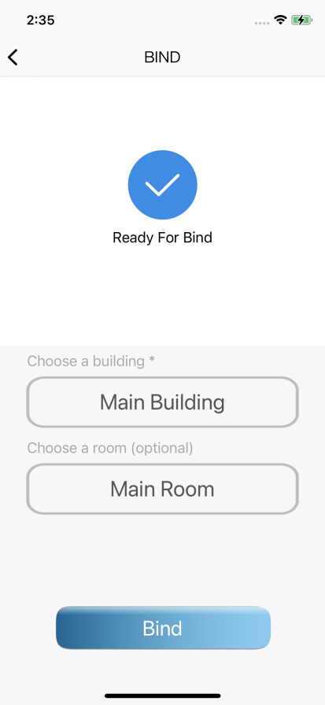 |  | 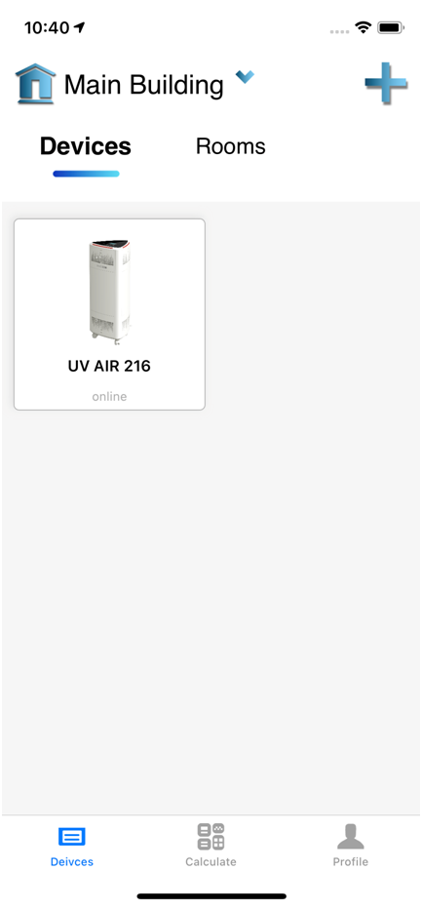
4. Select the device from the list of “Local Devices Discovered”. |  | 5. Choose “Main Building” and click “Bind”. (you can also choose “Main Room” as an option) |  | 6. You can find the device(s) in the “Main Building” and “Rooms”

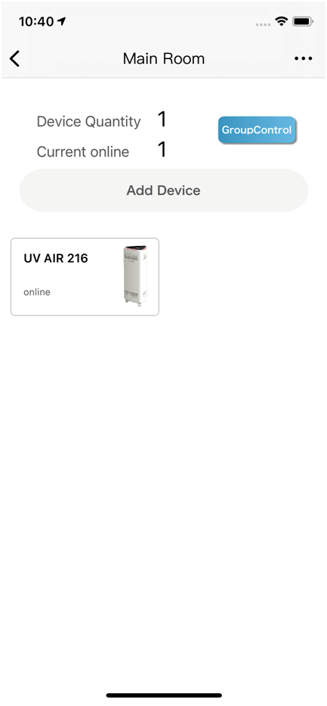 |  | 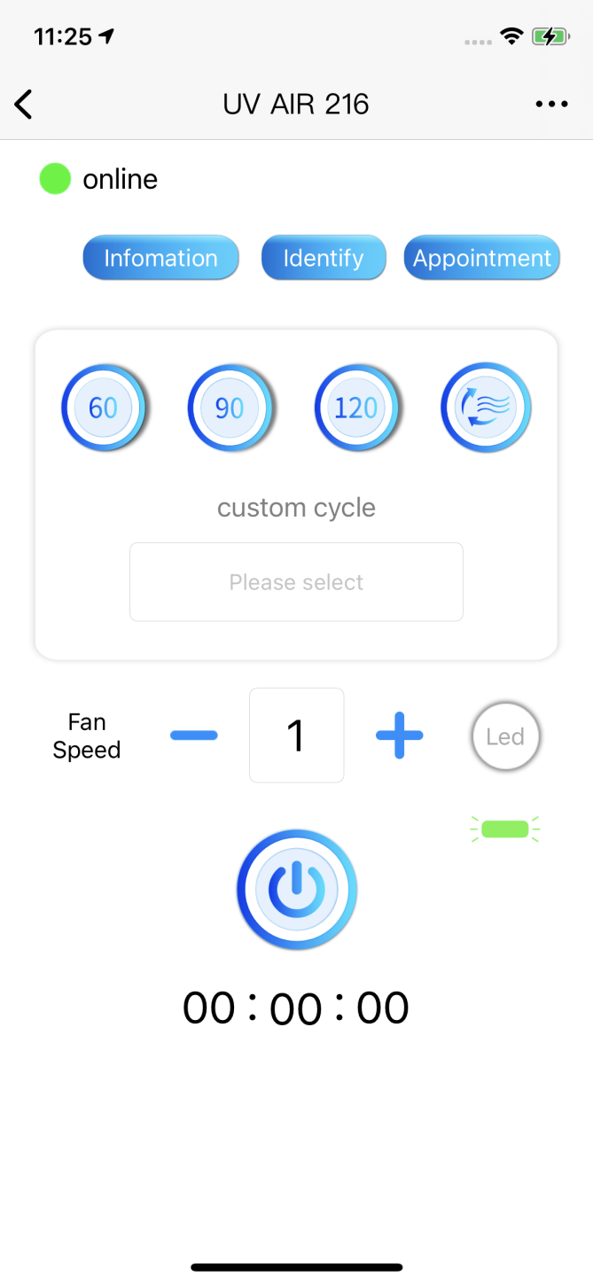
7. Now you can control the device from the APP.

Moving The Unit
This product has been integrated with 3 universal wheels for fast and easy relocation.  Before moving the product, make sure the power cable is disconnected from power socket.  Simply push the brake lever down to engage the brake; or lift the lever to release the brake.  * Always place the product on a stable and flat surface with the universal wheels brakes engaged during use or storage. | 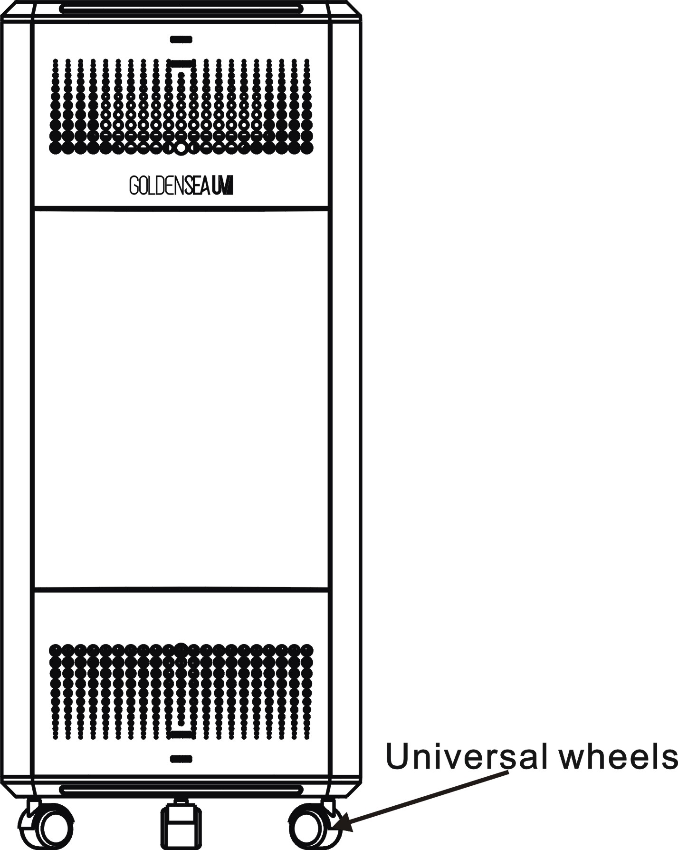

Fall Protection

When a working product detects a movement of more than 45°, it will automatically stop working for protection purpose.  There will be audio alarm and flashing green indicator light to alert the operator.  To make it work again after fall protection, put the product back to the normal upright position, make sure the power plug is still well-connected to power socket, re-start the operation again from the beginning. | 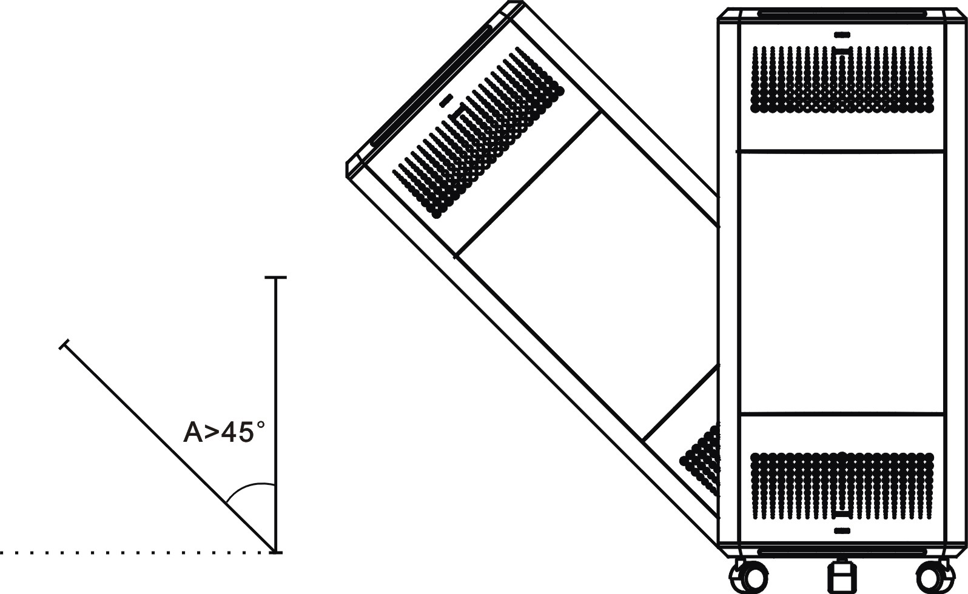

Open Door Protection

If the front door of the product is opened during use by accident or by misuse, the product will automatically turn off for protection purpose.  There will be audio alarm and flashing green+blue indicator lights to alert the operator.  Once the door is closed again, the operation process will continue.  The front door can be closed or opened by simply pushing in on the right side of the door. | 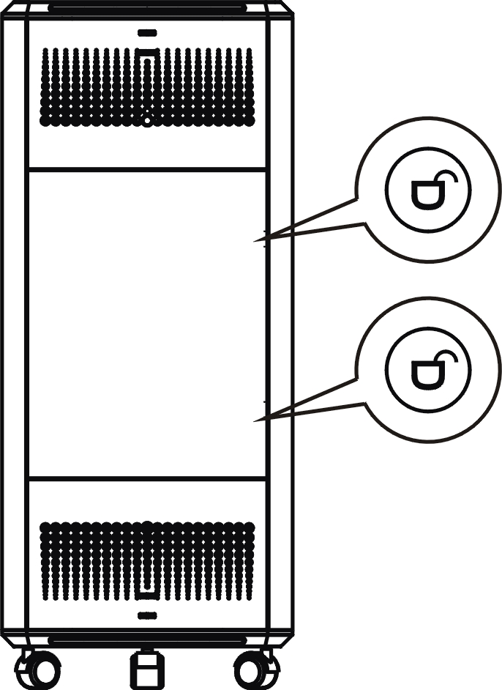

* The other two doors can be opened by pushing out from inside.
* Do not open the doors unless there is need for service or maintenance.

Dimensional Drawings

Replacing and Cleaning The Filters

• Always turn off the product and unplug from the socket before replacing the filters.
• The HEPA and Active Carbon Filters are not washable or reusable.
• Before carrying out any replacement and cleaning, wait about 15 minutes after switching off the product (to let the UV tubes cool down to avoid scalding).

8.1 Replacing the HEPA and Active Carbon Filters

Filter Replacement Indicator:
This product is equipped with a filter replacement indicator to make sure that the air purification filter is in optimal condition when operating. When the filters need to be replaced, the icon of “Filter Replacement Indicator” turn from white to red and stay flashing.
Replace the filters as soon as possible.

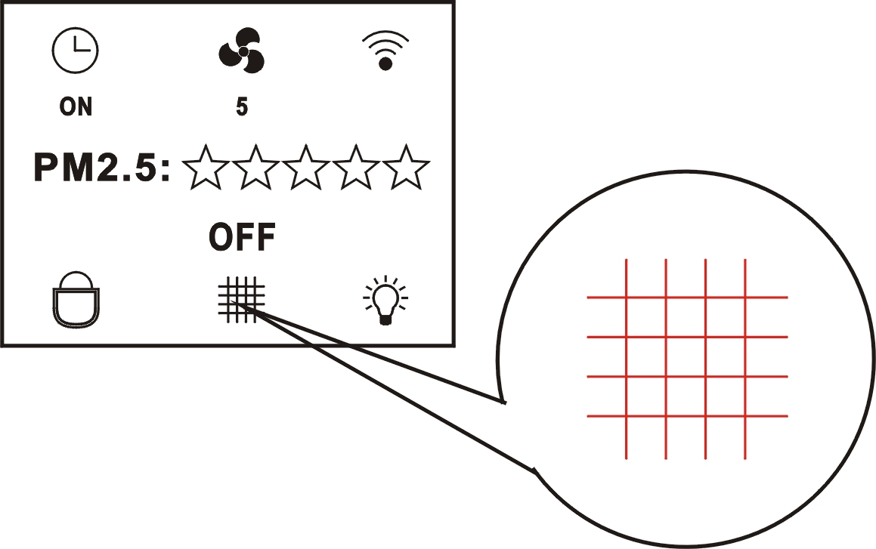

Steps:
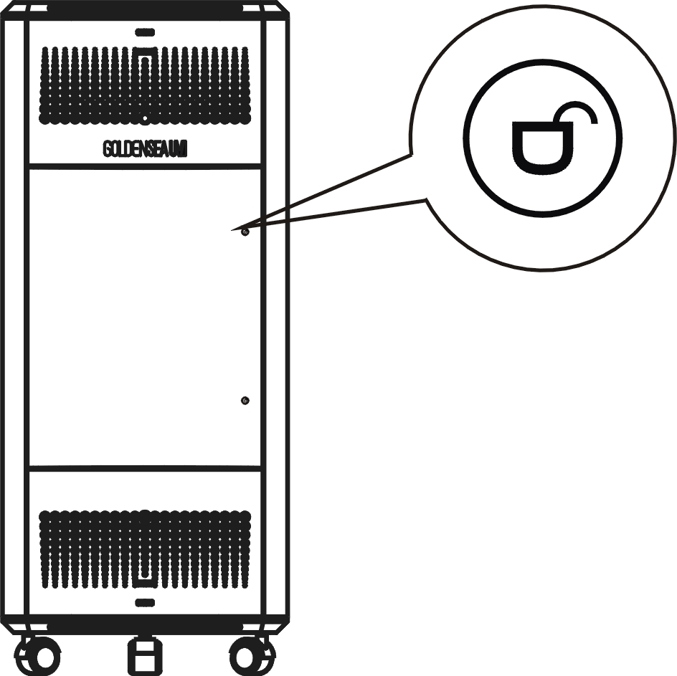 |  | 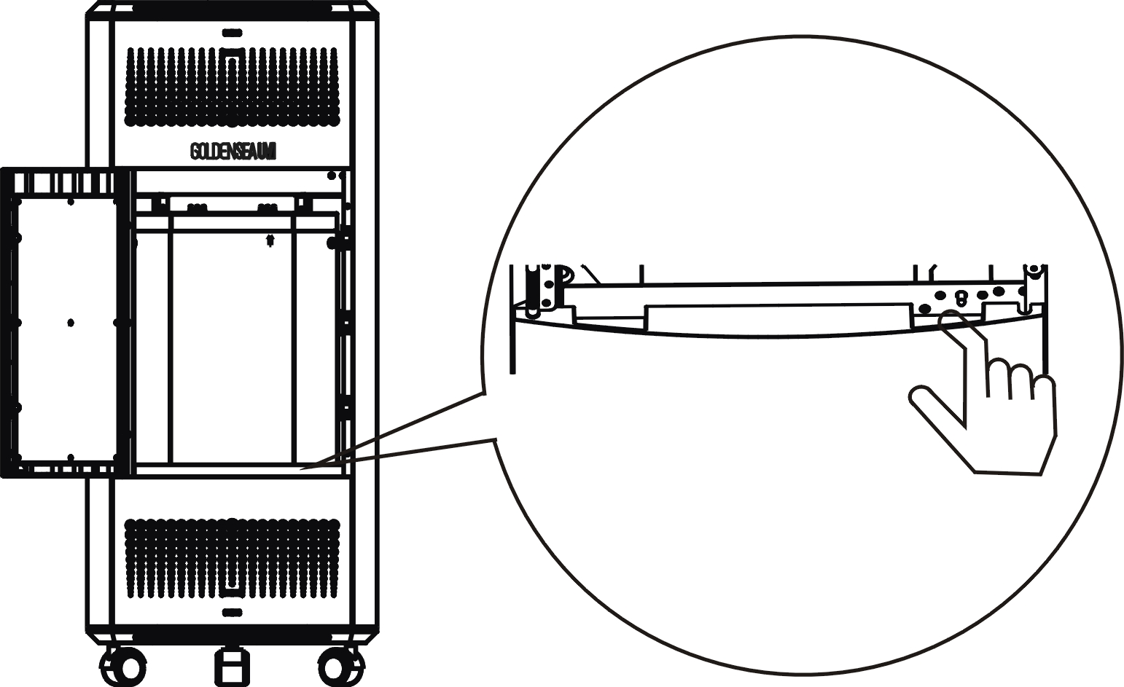
1. Push in on the right side of the front door and release to open.  * The other two doors can be opened by pushing out from inside. |  | 2. Remove the air inlet cover by simply pulling it out.

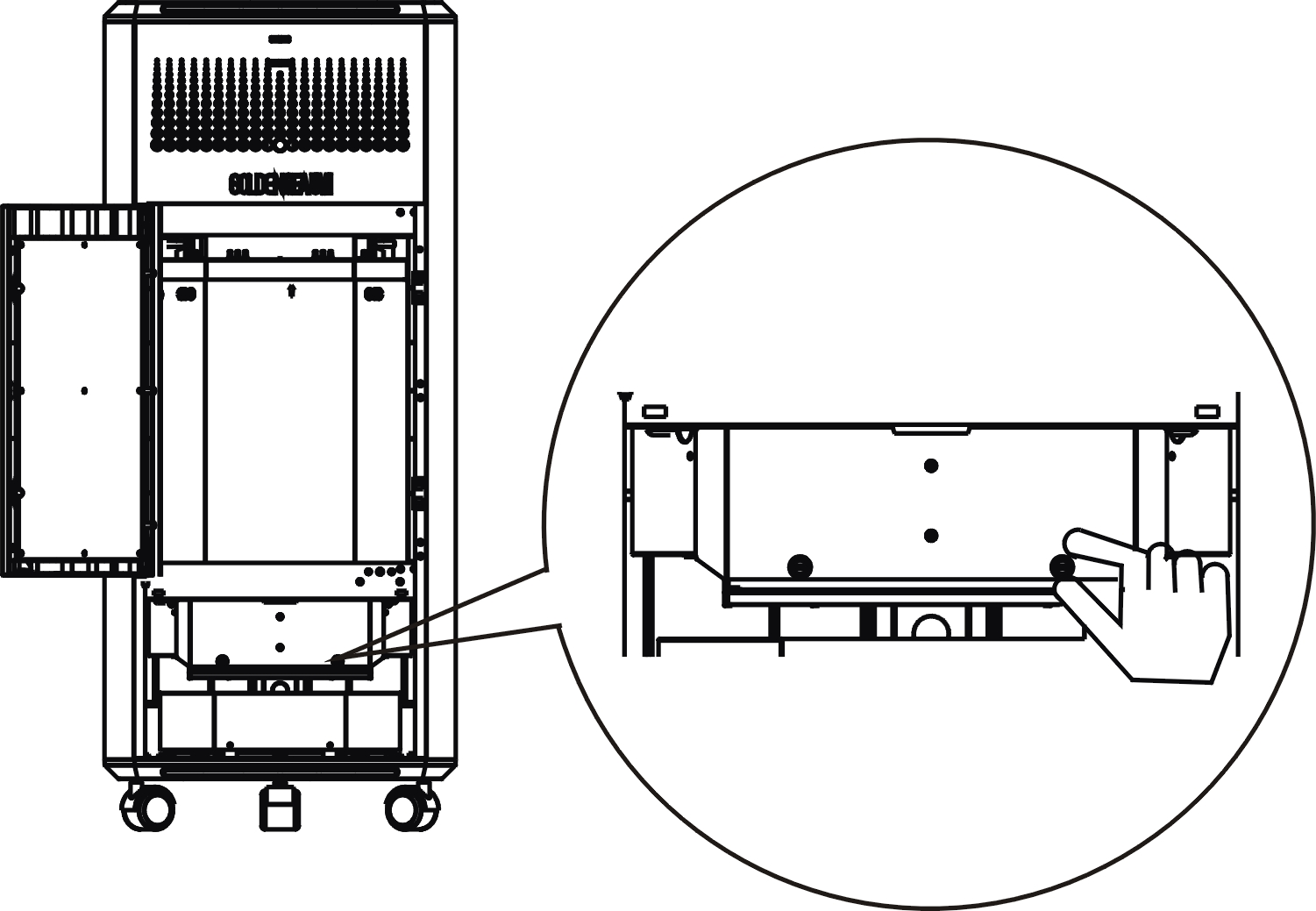 |  |  |  | 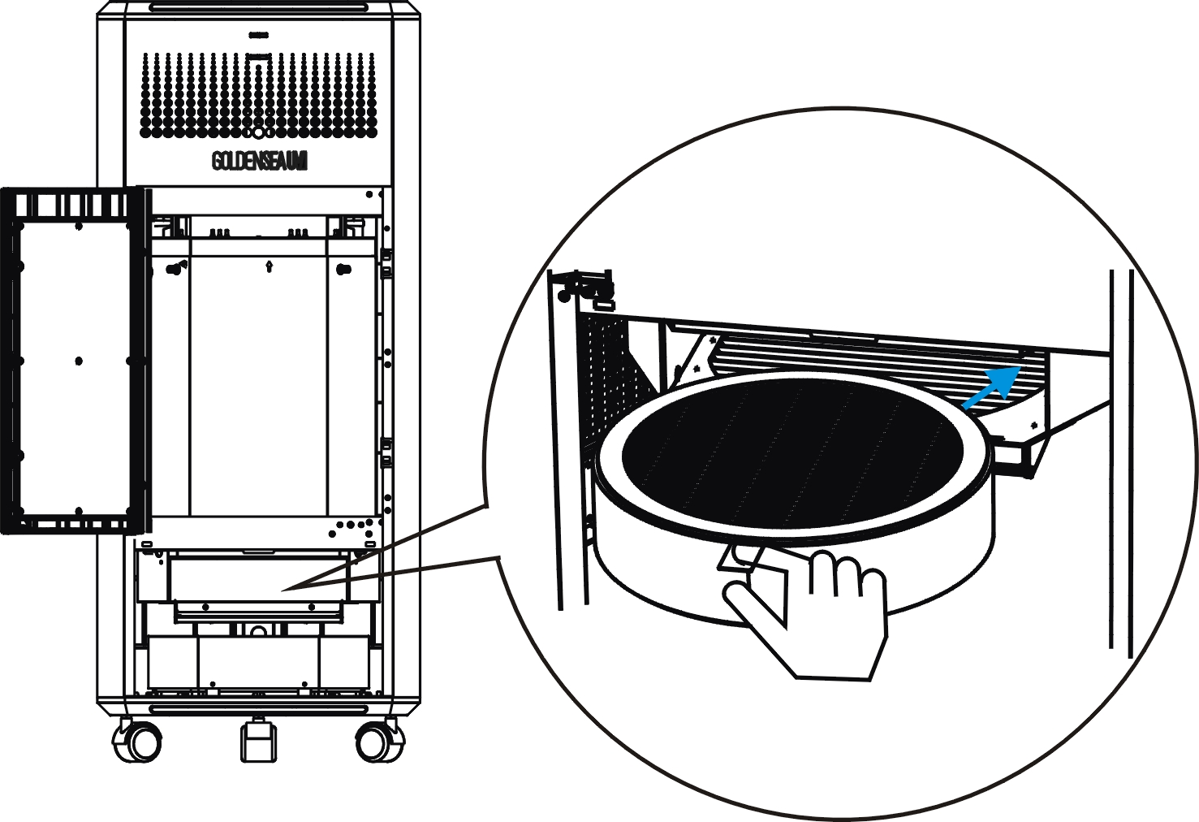
3. Loosen the 2 screws and remove the HEPA cover.  * If the screws are too tight to turn by hand, use a screwdriver to loosen them first. |  |  | 4. Remove the current HEPA by simply pulling it out holding the strip.  Now install a new HEPA, re-install the HEPA cover and tighten the 2 screws, re-install the air inlet cover.

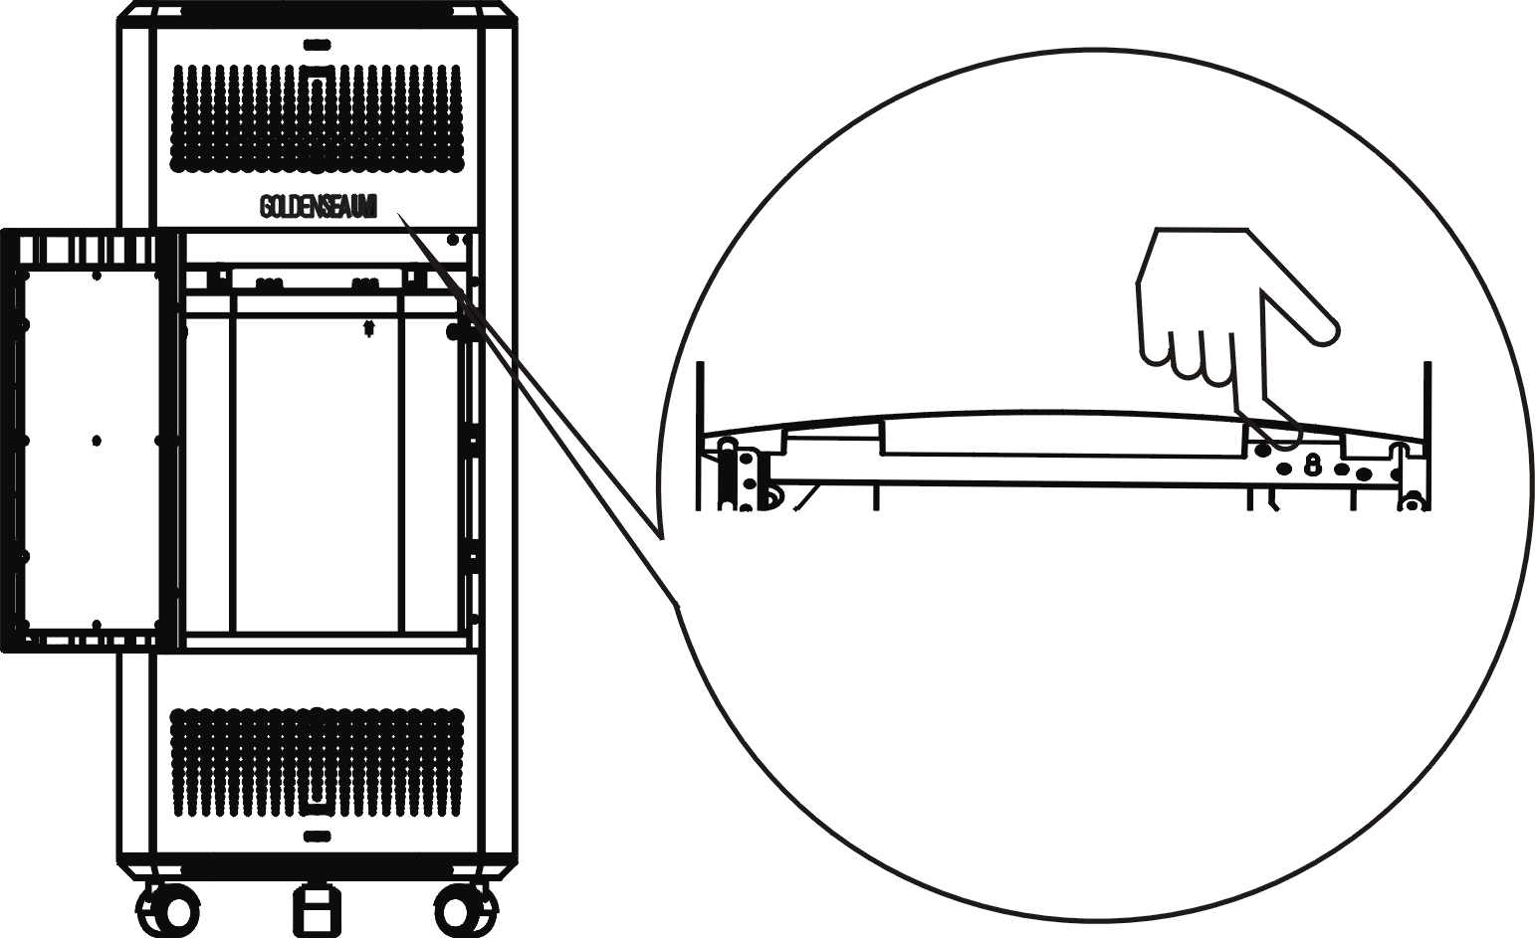 |  |  |  | 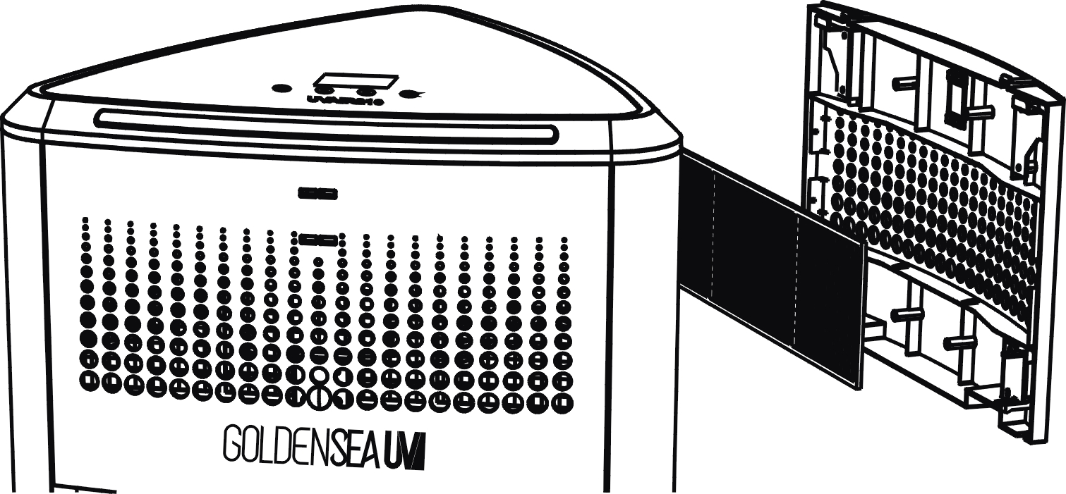
5. Remove the air outlet cover by simply pulling it out. |  |  | 6. Remove the current Active Carbon Filter by simply pulling it out.  Now install a new Active Carbon Filter, re-install the air outlet cover, push in the door to close.
The product is now ready for use again.
* After filters replacement, remember to reset the filter hours in the display menu: select the icon and pressing for 5 seconds to reset.

8.2 Clean the Pre-filters

The Pre-filters need to be checked and cleaned regularly to avoid dust accumulated and wind flow efficiency reduced.
• Do not clean the Pre-filters with a vacuum.
• If the pre-filter is damaged, worn or broken, do not use.

Steps:
 |  | 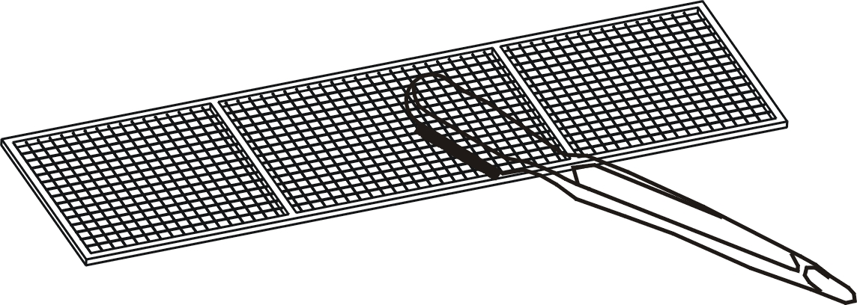
1. Push in on the right side of the front door and release to open.  * The other two doors can be opened by pushing out from inside. |  | 2. Remove the air inlet cover by simply pulling it out.  Take out the Pre-filter and clean with a brush. After cleaning, re-install it back.

Replacing The UV Lamps

To maintain the sterilizing efficacy, the UV tubes need to be replaced after 9,000 hours of use. When the lamps need to be replaced, the icon of “Lamp Replacement Indicator” turn from white to red and stay flashing.
If the lamps are not replaced in time, the product will stop operating and automatically lock to protect the disinfection effect in the room. Replace the lamps as soon as possible.
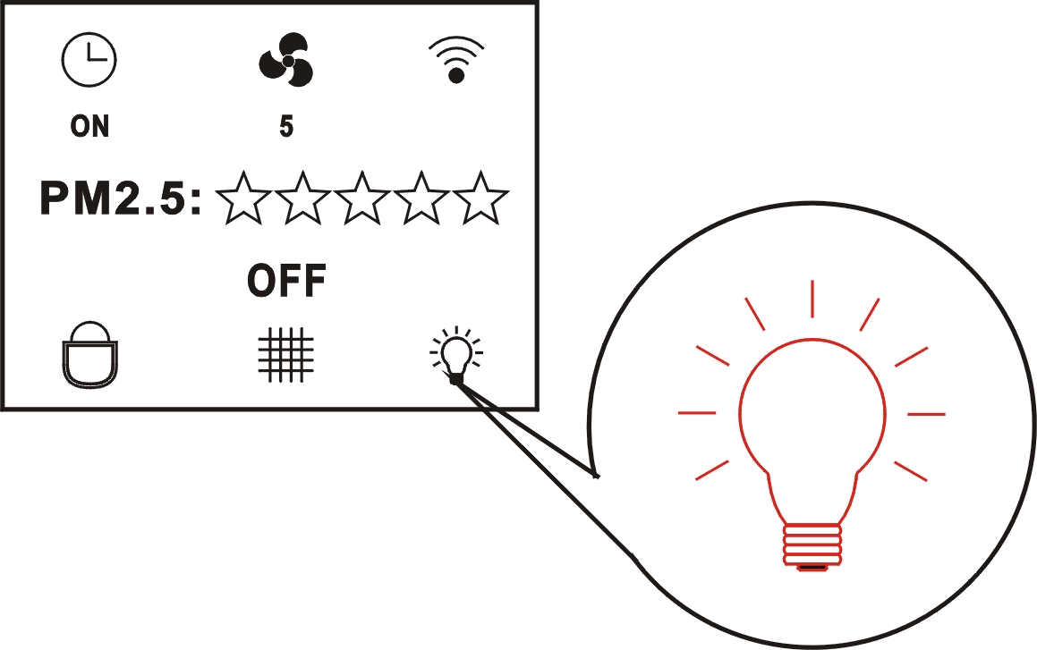
• Before carrying out any replacement, wait about 15 minutes after switching off the product (to let the UV tubes cool down to avoid scalding).

Steps:

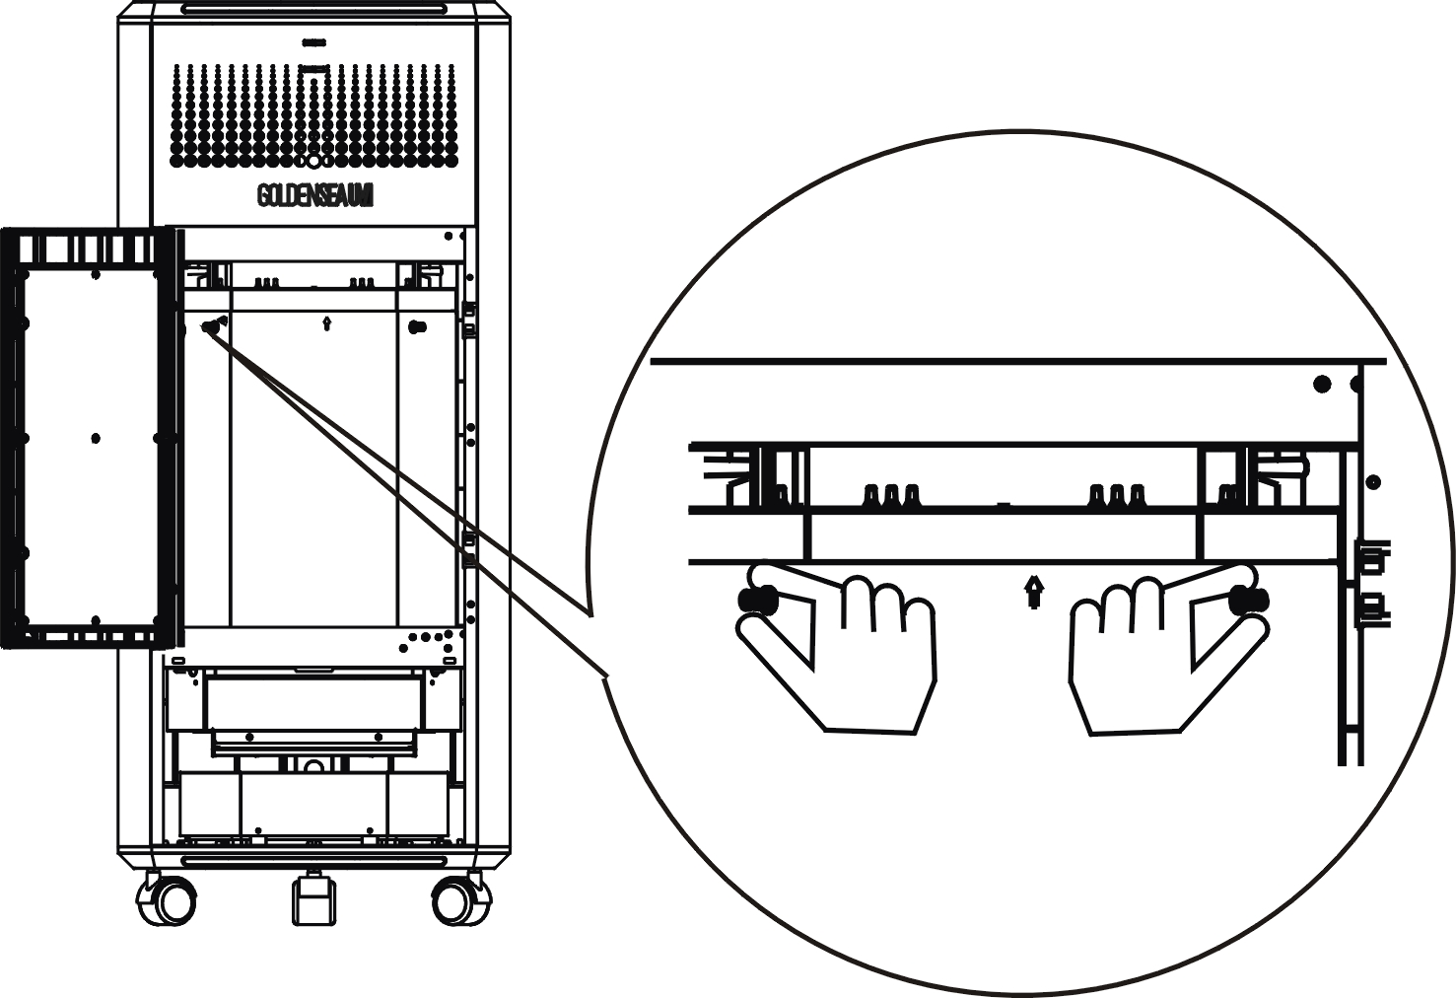
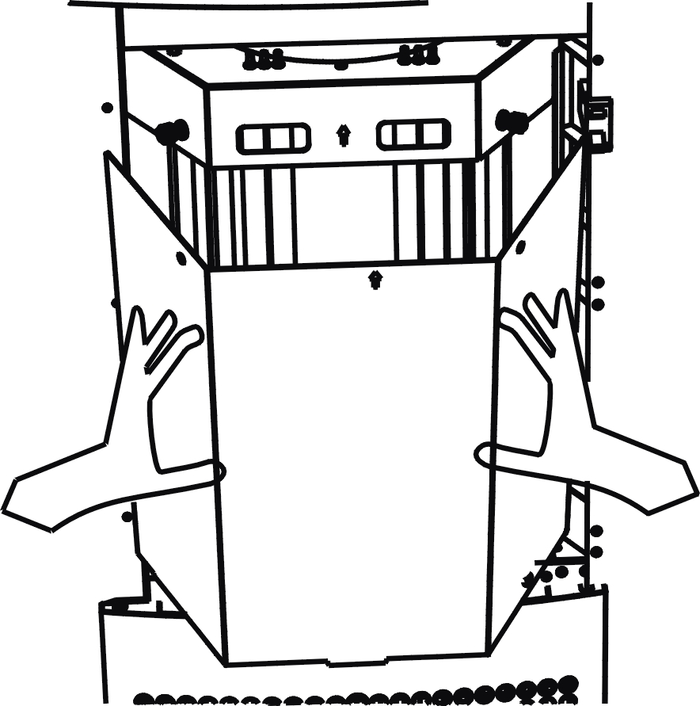
1. Push in on the right side of the front door and release to open.  * The other two doors can be opened by pushing out from inside. |  | 2. Loosen the 2 screws and remove the UV shield cover by pulling it out.  * If the screws are too tight to turn by hand, use a screwdriver to loosen them first.

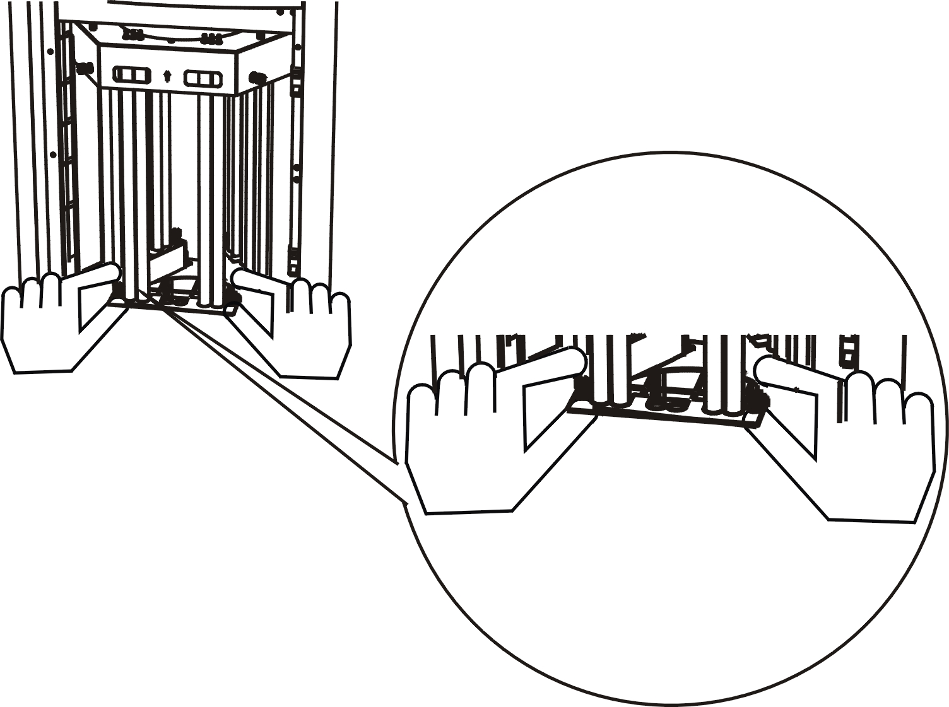 |  | 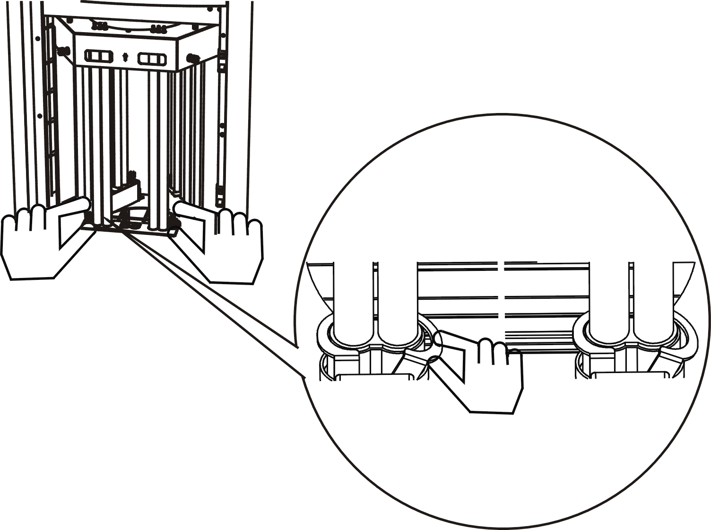
3. Loosen the 2 screws of the UV tube holder cover and remove the metal cover.  * Be careful when removing the metal cover to avoid damage to UV tubes. |  | 4. Turn the two clips downwards on both sides of the UV tube holder.

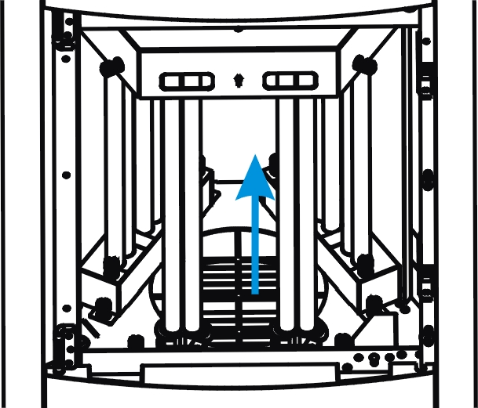
5. Move the current UV tube out of its holder upwards and take it out. |  | 6. Now install a new UV tube into the holder and push it downwards until it fits into place correctly and tightly, turn the two clips upwards on both sides.

5. Re-install the UV tube holder cover and tighten the 2 screws. |  | 6. Re-install the UV shield cover and tighten the 2 screws.  Push in on the right side of the door to close.
The product is now ready for use again.
* After lamps replacement, remember to reset the lamps hours in the display menu: select the icon and pressing for 5 seconds to reset.
* Note: please follow your local toxic and hazardous waste regulations for lamp disposal.

Troubleshooting Tips

10.1 What to do if the product doesn’t work?

- Ensure the product is plugged into a working socket, plug is wired correctly and terminal well-connected.
- Ensure the power switch is switched to “on” < I >.
- Check if the door is opened by accident or misuse. Push the door in to close it.

10.2 How often should the UV tube be replaced?

- The UV tube is the core of the product, it should be replaced after 9000 hours of use to maintain the germicidal efficacy. If it needs to be replaced, the icon on display will turn from white to red.
- If the UV tube is defected or damaged, please contact your local dealer or our customer service to order a new UV tube. For replacing the UV tube, please refer to the instructions in this user manual.
- After use for a period of time, it is normal to find some black spots on the UV tube.

10.3 Why airﬂow coming out from the air outlet is significantly weaker than before?
1. Check if the pre-filter is dirty, if so, clean the pre-filter.

10.4 Why the display still show the alert icon of replacing filter/lamp even after it is just replaced?
1. Check if you have reset the filter/lamp in the display menu after replacement.

Features

Light Source
• Lamp: TUV PL-L 36W/4P 1CT/25 (PHILIPS) or
HNS L 36W 2G11 GFT36DL/2G11/SE/OF PURITEC UV-C Germicidal Low Pressure Lamp (OSRAM)
• The UV-C wavelength is 253.7nm.
• Extremely long Life: up to 9,000 H

Features
• Disinfection time settings  • Fan speed settings  • Control panel with touch keys  • Remote control  • Control with APP | • Visual indicator lights  • Audio alarm  • Power switch  • Movable with wheels  • Fall protection

Product Type  • Commercial Air Purifier | Weight  • Net weight: 27 kg

Cleaning and Maintenance

- To ensure the device remains in good condition and does not fail prematurely, regular maintenance, cleaning and checks are required.
2. For cleaning of the device, please use a lint-free cloth.
3. To avoid damage to the device, never use detergent or solvents.
4. Never spray insecticide towards the device, it can discolor or damaged.
5. Should you need any spare parts, please order genuine parts from your local dealer.

Recycling

To protect the environment and human health, do not throw away the product with the normal household waste at the end of its life, hand it to your local collection point for recycling. Follow local rules for the separate collection of electrical and electronic products.

Service

For all service needs, please contact your local authorized dealer or GOLDENSEA customer service. Our contact details are:
Email: support@goldenseauv.com Tel: +86 20 3996 6388
Address: No.109 Haiyong Road, Shiji Town, Panyu Zone, Guangzhou, China. 511450

Errors and omissions for all information given in this user manual are expected.
All information is subject to change without prior notice.



